

**Supportive Learning**

**Documentation**

|  |  |
| --- | --- |
| **Group 242** | |
| **Group Member** | Luan Vu Van  Luong Dinh Minh |

- Hanoi, 01/2014 –

**Index**

**1.** **Installation software.** 3

**1.1.** **Mysql installer community 5.6.15.0** 3

**1.2.** **JDK 7u45 Windows x64** 7

**1.3.** **Netbeans 7.4 windows.** 9

**1.4.** **Add Library.** 13

**2.** **Attach Database.** 14

1. **Installation software.**
   1. **Mysql installer community 5.6.15.0**

* Run file: mysql-installer-community-5.6.15.0.msi

As shown below:

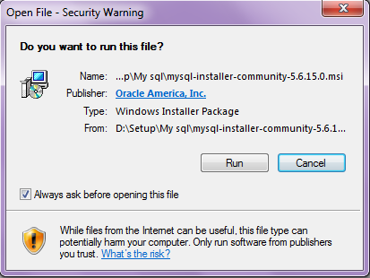

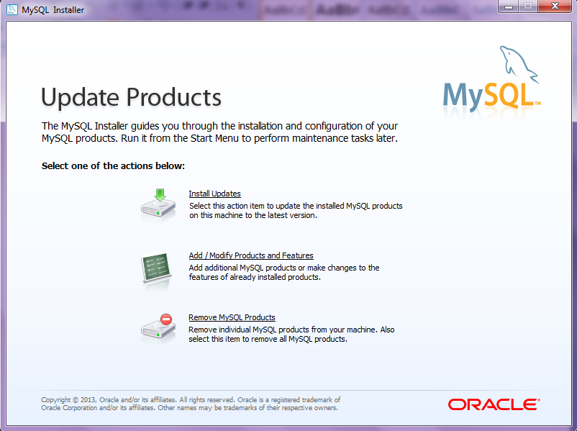

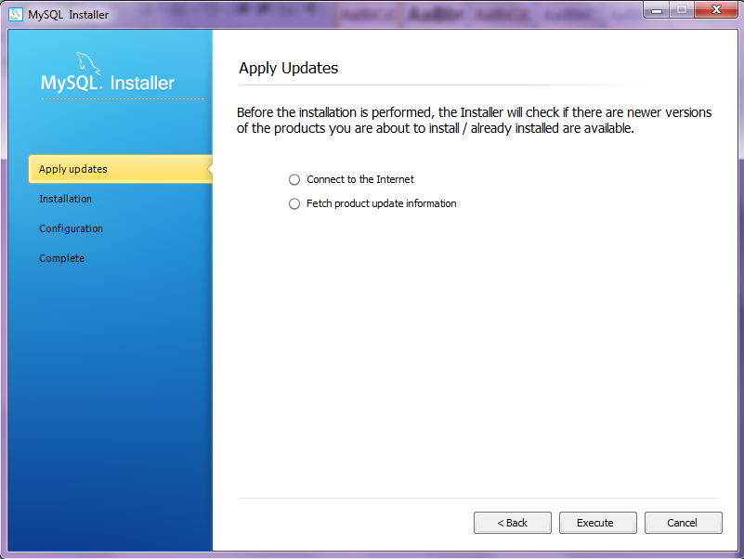

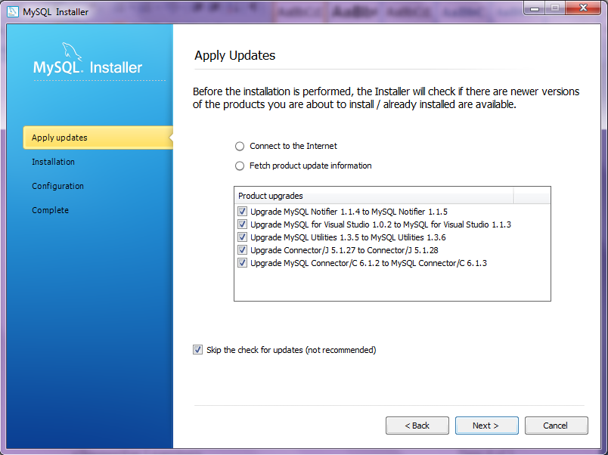

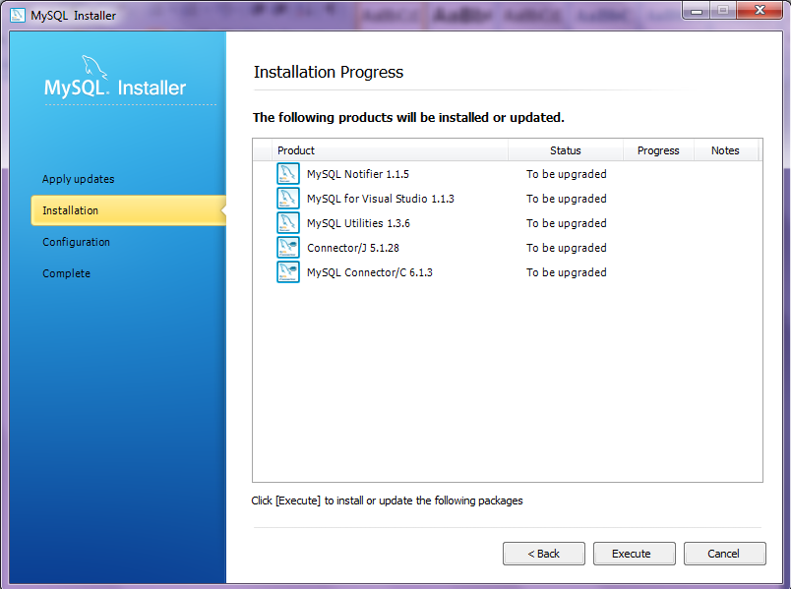

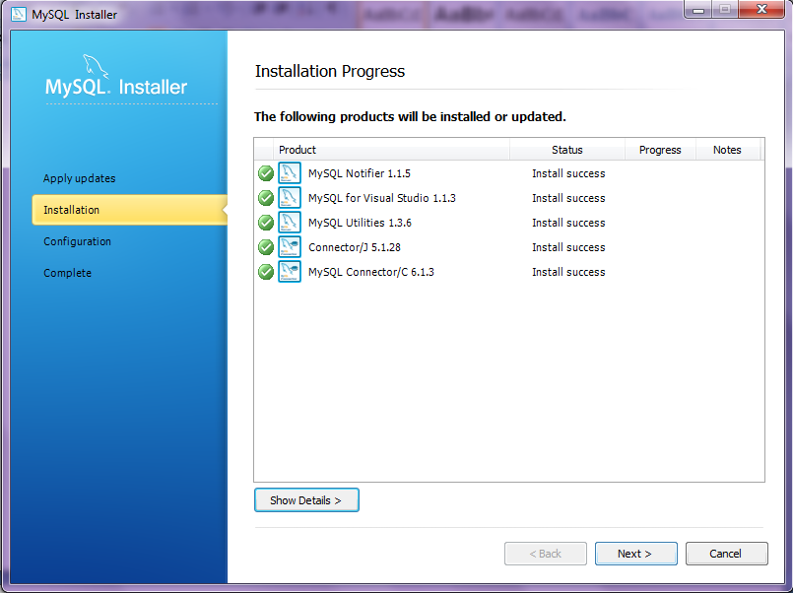

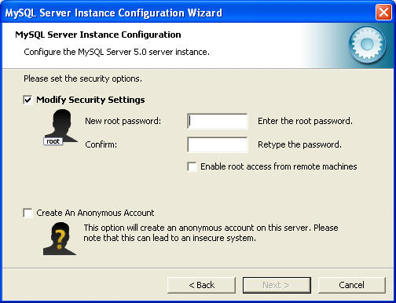

* Username: root
* Password: 123456

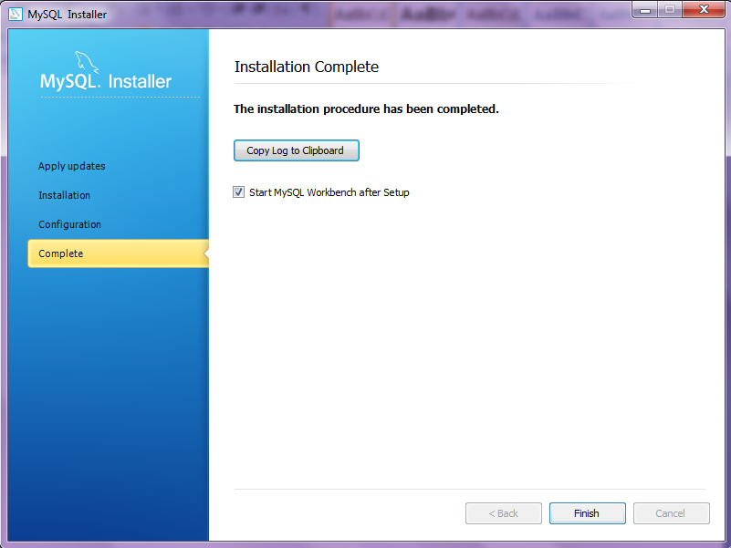

* 1. **JDK 7u45 Windows x64**
* Run jdk-7u45-windows-x64.exe

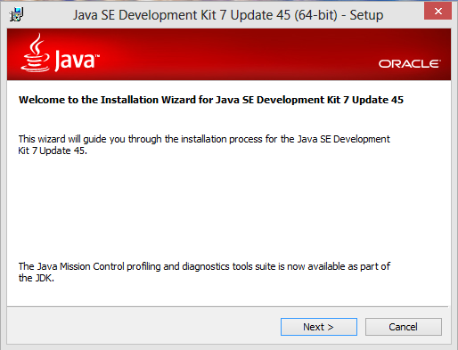

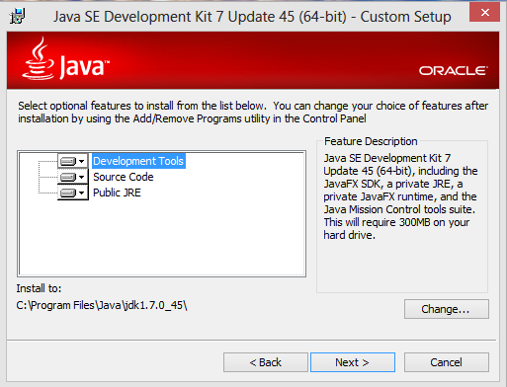

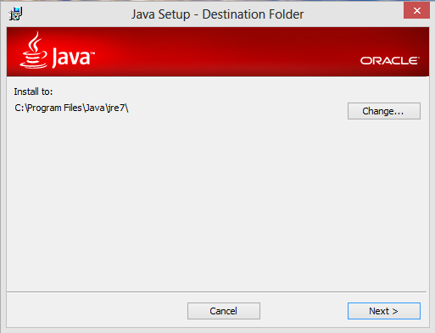

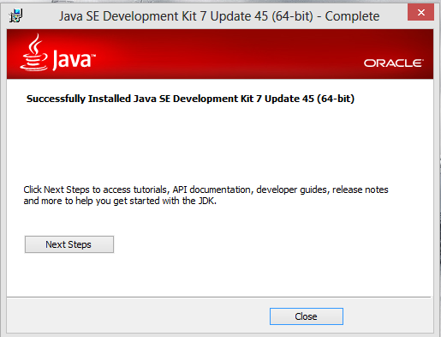

* 1. **Netbeans 7.4 windows.**
* Run netbeans-7.4-windows.exe

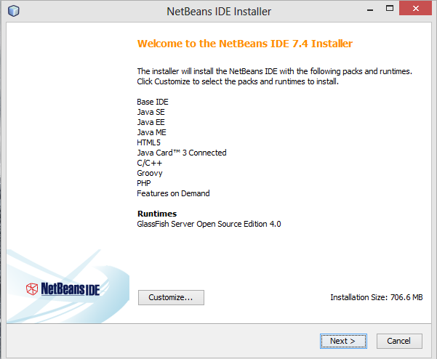

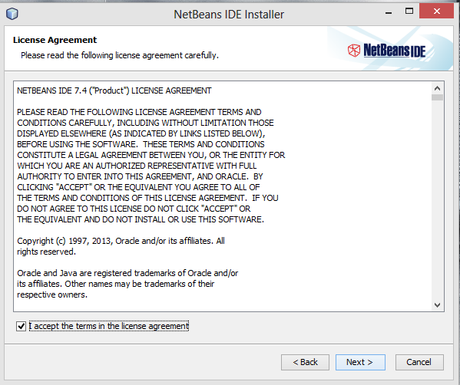

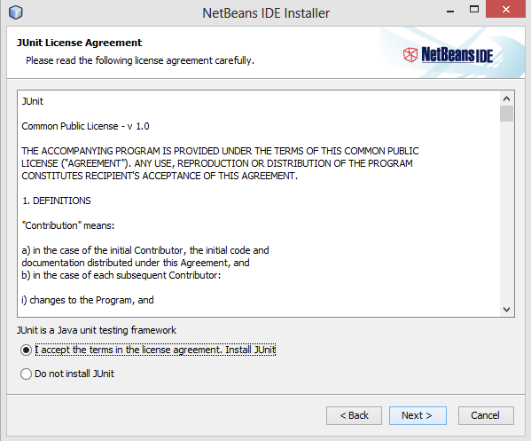

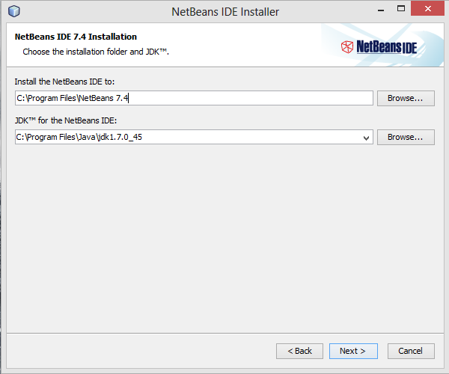

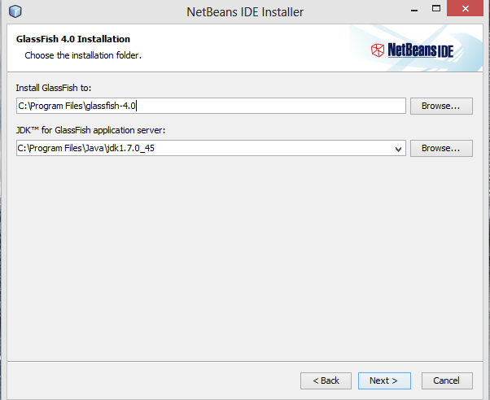

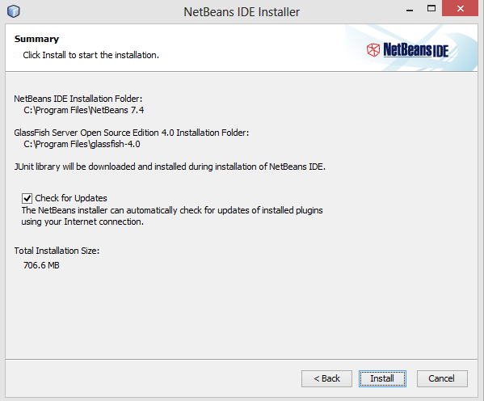

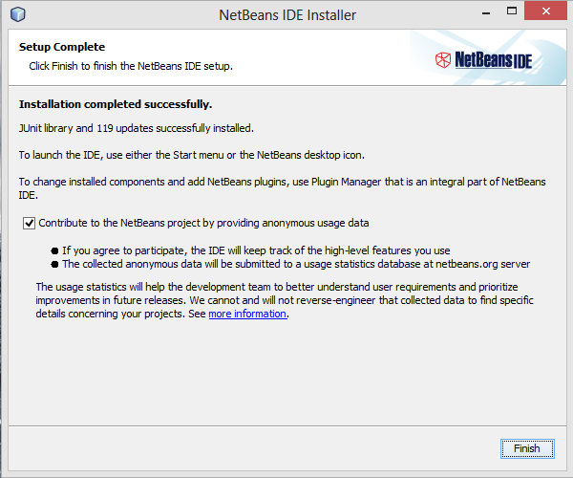

* 1. **Add Library.**
* Run NetBeans 7.4
* Open Project
* Click right mouse on Libraries
* Choose Add JAR/Folder

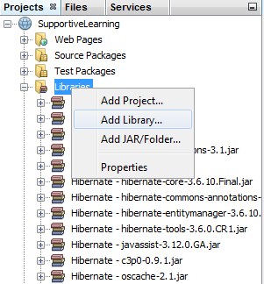

* Select field and click Open.

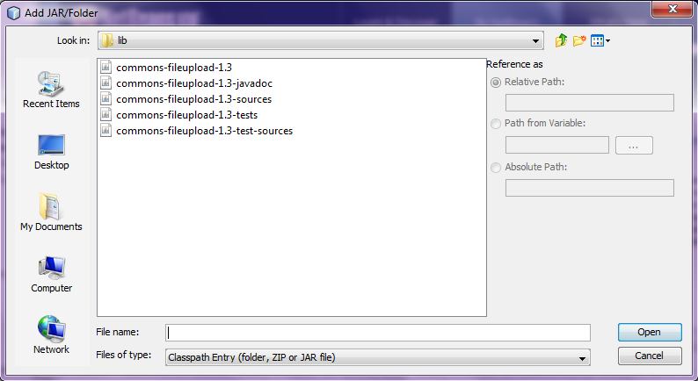

* *List Library :*
* javax.faces-2.2.5.rar
* mysql-connector-java-5.1.27-bin.rar
* omnifaces-1.6.3.rar
* primefaces-4.0.rar
* primefaces-4.0-sources.rar
* primefaces-4.0-sources.rar
* commons-fileupload-1.3-javadoc.rar
* commons-fileupload-1.3-sources.rar
* commons-fileupload-1.3-tests.rar
* commons-fileupload-1.3-test-sources.rar

1. **Attach Database.**

* Run MySQL Workbench

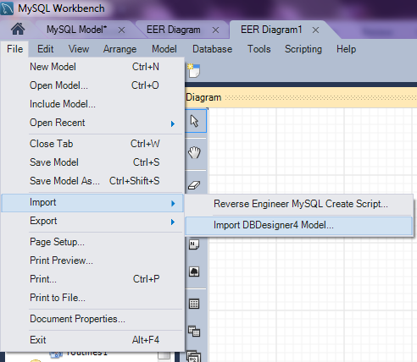

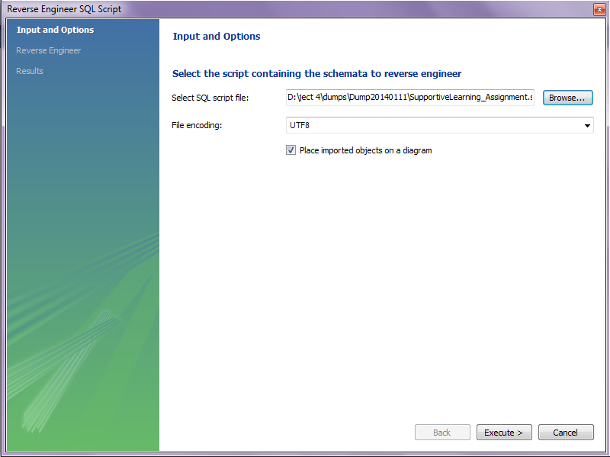

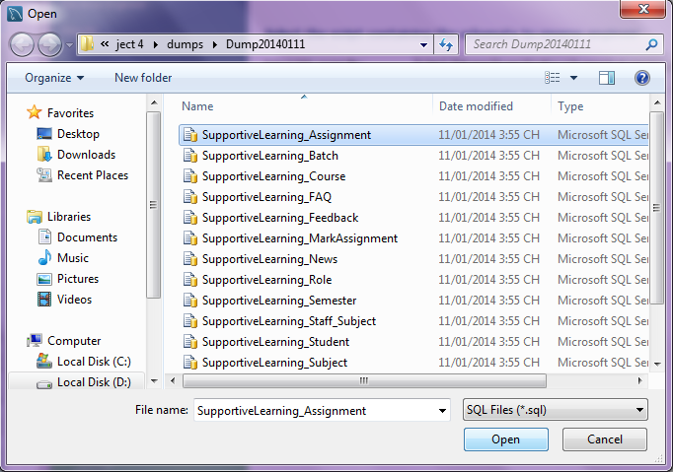

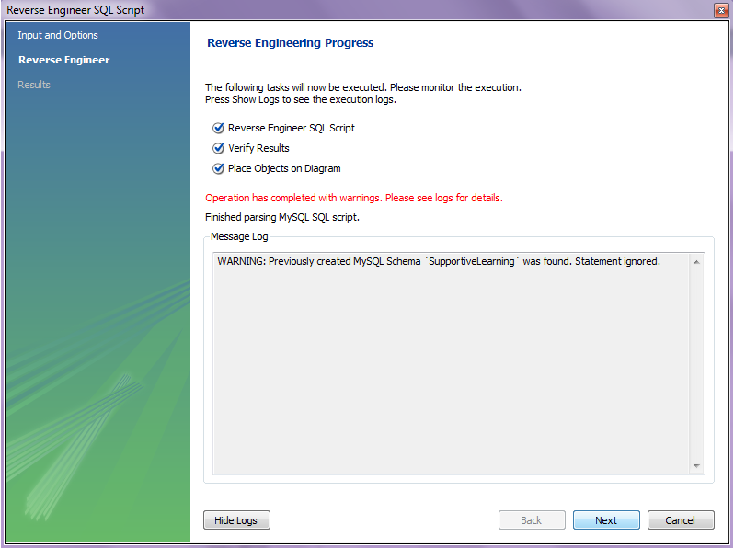

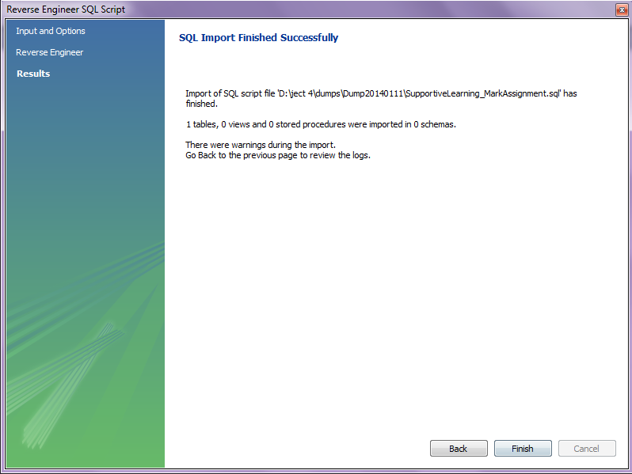

THE END.